Univariate and Bivariate Analysis – Capstone project
Univariate
- Mean, Median, Mode
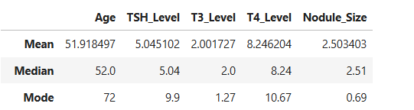
Feature | Normal Range | Dataset Median | Dataset Mode
TSH Level (mIU/L) | 0.4 – 4.0 | 5.04 | 9.9
T3 Level (nmol/L) | 1.2 – 2.8 | 2 | 1.27
T4 Level (µg/dL) | 4.5 – 12.0 | 8.24 | 10.67
Nodule Size (cm) | <1 cm benign;  >1 cm clinically significant | 2.51 | 0.69

- The Mean (average) Age around 51.9 implies most of the patients belong to around 50 age .
- The Mean (average) TSH_Level is around 5 implies average TSH_level is 5.
- The Mean (average) T3_level is around 2 implies most of the T3_Level is 2.
- The Mean (average) T4_Level is around 8.2 implies most of the T4_Level is 8.2.
- The Mean (average is around 2.5 implies most of the patients Nodule_Size is 2.5.
- The Median (middle value) Age is 52 years implies majority of patients fall in the middle-aged group.
- The Median (middle value) TSH_Level is 5.04 which means that half of the patients have TSH levels below 5.04, and the other half have levels above it.
- The Median (middle value) T3_level is around 2 implies majority of patients have T3 hormone levels within a normal range.
- The Median (middle value) T4_Level is around 8.24 majority of patients have T4 levels within a normal range.
- The Median (middle value) Nodule_Size is around 2.51 implies most patients have moderately sized thyroid nodules.
- The Mode (most common) Age is 72, means many patients belong to around 72 years.
- The Mode (most common) TSH_Level is 9.9, which indicates that many individuals have relatively high TSH levels compared to the normal range.
- The Mode (most common) T3_Level is 1.27, means that a large number of patients in the dataset have normal or slightly lower T3 levels.
- The Mode (most common) T4_Level is 10.67, indicates that a considerable portion of patients may exhibit slightly elevated T4 activity.
- The Mode (most common) Nodule size is 0.69cm, implying that small nodules are the most common among patients.

- Percentile Report
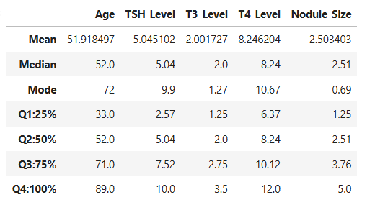
Age:
- The 25th percentile (Q1) is 33 — means 25% of patients are below 33 years.
- (Q2) 50% of the Age column is 52 — means half of the patients are below 52, indicating that most patients are middle-aged.
- From Q1 to Q2 there is a 57.6% increase showing that a majority of patients are in the middle-aged range (33–52 years).
- The 75th percentile (Q3) is 71 — 75% of patients are below 71 years.
- There is about a 36.5% rise in age from the median (52 years) to the 75th percentile (71 years), showing that the dataset includes a some portion of older patients.
- The maximum age (Q4) is 89 — indicating a few elderly patients in the dataset.
TSH_Level (Thyroid Stimulating Hormone):
- The 25th percentile (Q1) is 2.57, meaning 25% of patients have TSH levels below 2.57.
- The 50th percentile (Q2) or median is 5.04, meaning half of the patients have TSH levels below 5.04.
- From Q1 to Q2, there is a 96% increase, indicating that some patients have normal readings and some patients have elevated levels.
- The 75th percentile (Q3) is 7.52, meaning 75% of patients have TSH levels below 7.52.
- There is about a 49% rise in TSH levels from Q2 (5.04) to the 75th percentile Q3 (7.52), showing that some patients have higher-than-normal values.
- The maximum TSH value (Q4) is 10.0, indicating a few patients with very high TSH levels, possibly representing hypothyroid cases.

T3_Level (Triiodothyronine):
- The 25th percentile (Q1) is 1.25, meaning 25% of patients have T3 levels below 1.25.
- The 50th percentile (Q2) or median is 2.00, meaning half of the patients have T3 levels below 2.00.
- From Q1 to Q2, there is a 60% increase, indicating that most patients’ T3 levels are within the normal range.
- The 75th percentile (Q3) is 2.75, meaning 75% of patients have T3 levels below 2.75.
- There is a 37.5% increase from the median to the 75th percentile, showing a few patients with relatively higher T3 values.
- The maximum T3 value (Q4) is 3.5, indicating that some patients may have slightly elevated T3 levels suggestive of hyperthyroid tendencies.
T4_Level (Thyroxine):
- The 25th percentile (Q1) is 6.37, meaning 25% of patients have T4 levels below 6.37.
- The 50th percentile (Q2) or median is 8.24, meaning half of the patients have T4 levels below 8.24.
- From Q1 to Q2, there is a 29.4% increase, showing a moderate rise in T4 levels within the normal range.
- The 75th percentile (Q3) is 10.12, meaning 75% of patients have T4 levels below 10.12.
- There is a 22.8% increase from the median to the 75th percentile, showing that some patients have slightly elevated T4 levels.
- The maximum T4 value (Q4) is 12.0, indicating a few patients with high T4 readings, reflecting mild hyperthyroidism.

Nodule_Size (cm):
- The 25th percentile (Q1) is 1.25, means 25% of patients have nodules smaller than 1.25 cm.
- The 50th percentile (Q2) or median is 2.51, meaning half of the patients have nodules smaller than 2.51 cm.
- From Q1 to Q2, there is a 100.8% increase, indicating that nodule size roughly doubles between these percentiles.
- The 75th percentile (Q3) is 3.76, meaning 75% of patients have nodules below 3.76 cm.
- There is a 49.8% increase from the median to the 75th percentile, showing some patients with moderately large nodules.
- The maximum nodule size (Q4) is 5.0, indicating the presence of a few large nodules in the dataset.

- Distribution plots
Distribution plots help you understand how each numeric feature is spread – like normal, right skewed, Left skewed, Uniform. They also help in visually spot outliers and understand data concentration.
Age:
The Age distribution is fairly uniform across all ranges, indicating a balanced representation of younger, middle-aged, and older patients without significant skewness.
TSH_Level:
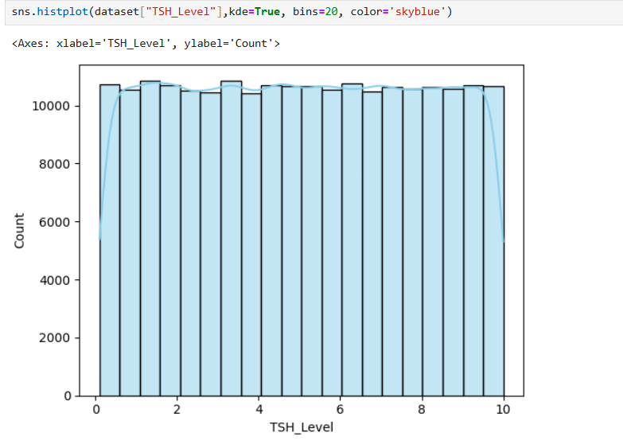
The distribution of TSH_Level appears fairly uniform with slight variations across the range, indicating that patients have a wide spread of TSH values. Most patients have normal to moderately elevated TSH levels, showing no strong skewness in the data.

T3_Level:
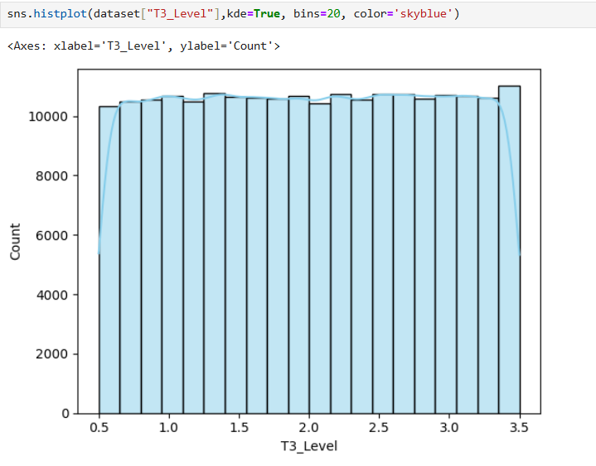
The distribution of T3_Level appears relatively uniform, suggesting that T3 values are evenly spread across patients. The data shows no strong skewness.
T4_Level:
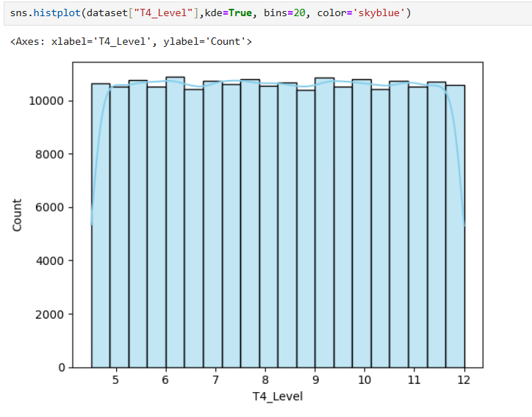
The distribution of T4_Level is fairly uniform across patients, indicating that T4 values are spread evenly without significant skewness. This suggests that most patients have T4 levels within the normal range.
Nodule size:
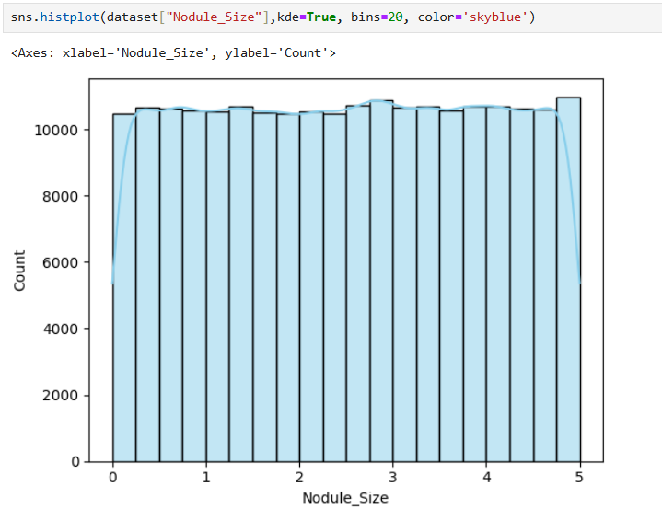
The distribution of Nodule_Size appears fairly uniform, indicating that nodule sizes are evenly spread across patients. This suggests there is no strong concentration of very small or very large nodules, and the dataset represents a balanced range of nodule measurements.
- IQR (Inter Quartile Range)
The IQR helps identify outliers and understand the spread of the numerical data.
IQR=Q3−Q1
 | Age | TSH_Level | T3_Level | T4_Level | Nodule_Size
IQR | 38 | 4.95 | 1.5 | 3.75 | 2.51
1.5rule | 57 | 7.425 | 2.25 | 5.625 | 3.765
Lesser | -24 | -4.855 | -1 | 0.745 | -2.515
Greater | 128 | 14.945 | 5 | 15.745 | 7.525
Min | 15 | 0.1 | 0.5 | 4.5 | 0
Max | 89 | 10 | 3.5 | 12 | 5

By using formula in the python code we have found the lesser bound, Greater bound, Minimum value and Maximum value.
Age: Range: -24 to 128→ All ages (15 to 89) fall inside → So No Outliers
Age :
IQR = 38
Min = 15 > Lesser = -24
Max = 89< Greater = 128
Conclusion: No outliers in Age
TSH_Level :
IQR = 4.95
Min = 0.1 > Lesser = -4.8
Max = 10 < Greater = 14.9
Conclusion: No outliers in TSH_Level
T3_Level :
IQR = 1.5
Min = 0.5 > Lesser = -1
Max = 3.5 < Greater = 5
Conclusion: No outliers in T3_Level
T4_Level :
IQR = 3.75
Min = 4.5 > Lesser = 0.74
Max = 12 < Greater = 15.74
Conclusion: No outliers in T4_Level
Nodule_Size :
IQR = 2.51
Min = 0 > Lesser = -2.5
Max = 5 < Greater = 7.5
Conclusion: No outliers in Nodule_Size

- Skewness and Kurtosis:
Skewness: Measures the asymmetry of the data distribution.
Skew = 0 Perfectly symmetrical
Skew < 0.5 Fairly symmetric.
0.5 ≤ Skew< 1 Moderately skewed.
Skew ≥ 1 Highly skewed.
 | Age | TSH_Level | T3_Level | T4_Level | Nodule_Size
Skew | 0.004603 | 0.001629 | -0.003318 | 0.001979 | -0.004937
Kurtosis | -1.200477 | -1.20093 | -1.200503 | -1.199327 | -1.200245

The skewness values are close to zero, indicating that the data is nearly symmetric with no right or left tail.
Kurtosis:
It measures the “tailedness” of the distribution -> how heavy or light the tails are compared to a normal distribution.
Kurtosis = 0: Mesokurtic (normal distribution).
Kurtosis > 0: Leptokurtic — heavy tails, more outliers.
Kurtosis < 0: Platykurtic — light tails, fewer outliers
All kurtosis values are around –1.2, meaning the distributions are platykurtic.

Bivariate Analysis
  - Correlation:
Relation between two variables
Range: −1 to +1
- +1 → Perfect positive correlation (both increase together)
- −1 → Perfect negative correlation (one increases, the other decreases)
- 0 → No correlation (no linear relationship)

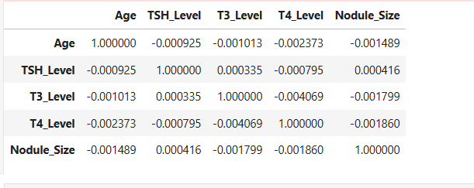

The correlation values between all numeric features are very close to 0, which means there is no significant linear relationship between them.

  - Hypothesis Testing
Hypothesis testing checks whether there’s a significant relationship or difference between two or more variables
- Null Hypothesis (H₀): There is no significant difference or relationship.
- Alternative Hypothesis (H₁): There is a significant difference or relationship.
ANOVA:
ANOVA (Analysis of Variance) is a statistical test used to check whether there are significant differences between the means of three or more groups.
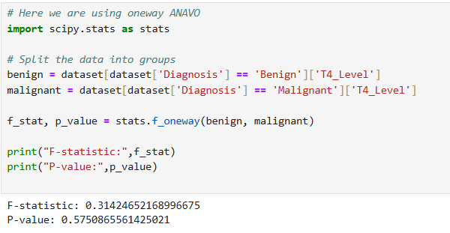
- Conclusion
if pvalue is < 0.05 we reject Null hypothesis
if pvalue is > 0.05 we accept Null hypothesis (fail to reject)
Here pvalue - 0.57 which is > than 0.05 ---> we are accepting Null hypothesis
hence there is no significant difference between T4_Level and Diagnosis of patients.
T-test :
A t-test is a statistical test used to compare the means (averages) of two groups.
Type | When to Use
Independent (Unpaired) t-test | Compare means of two different groups (T4 level and diagnosis)
Paired t-test | Compare two sets of related measurements (before vs. after TSH levels)

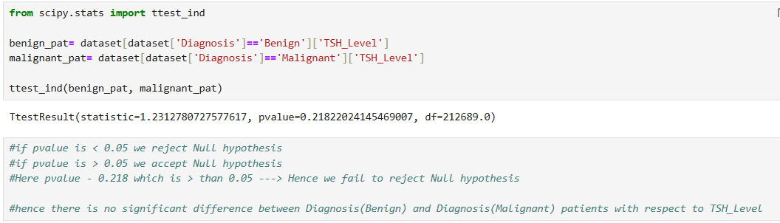
Converting Normal distribution to Std Normal distribution:
It is about standardizing the data — i.e., converting column (like TSH_Level, T3_Level, T4_Level,Age, etc.) to a standard scale.
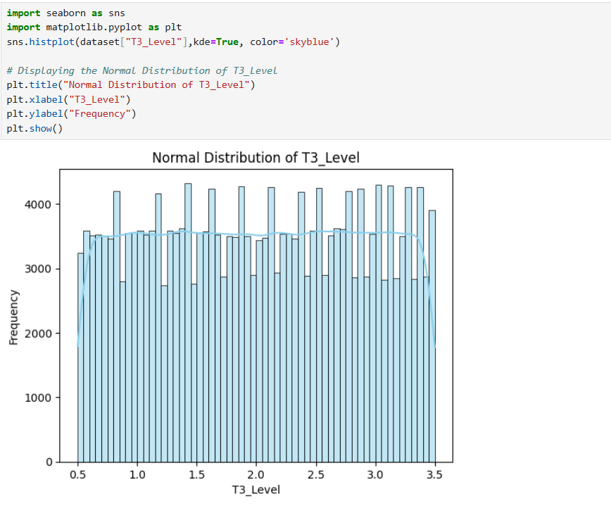
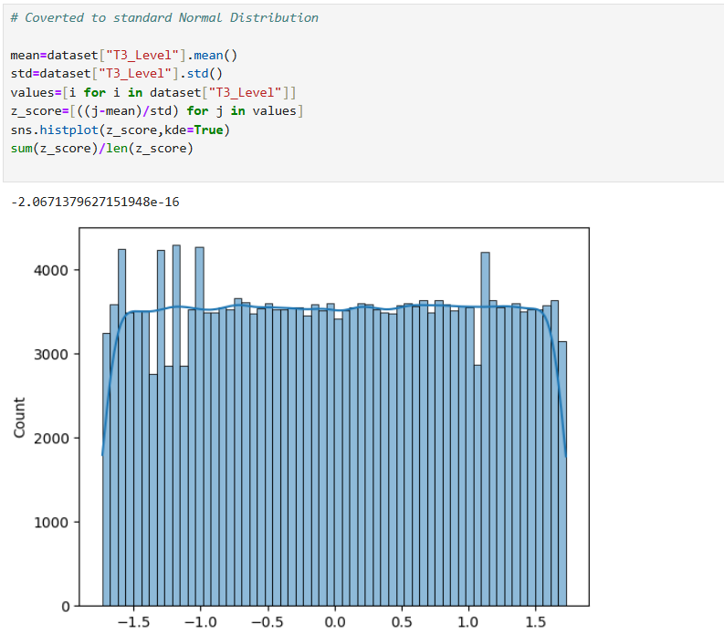
Data Visualization
EDA Questions and Answers
- How many patients are diagnosed as Benign and Malignant?
  - Benign 163196
  - Malignant 49495

- What is the percentage of patients by Thyroid_Cancer_Risk type?
  - Low 50.960313
  - Medium 34.039992
  - High 14.999694

- Display Top 10 patients with the highest Nodule Size?

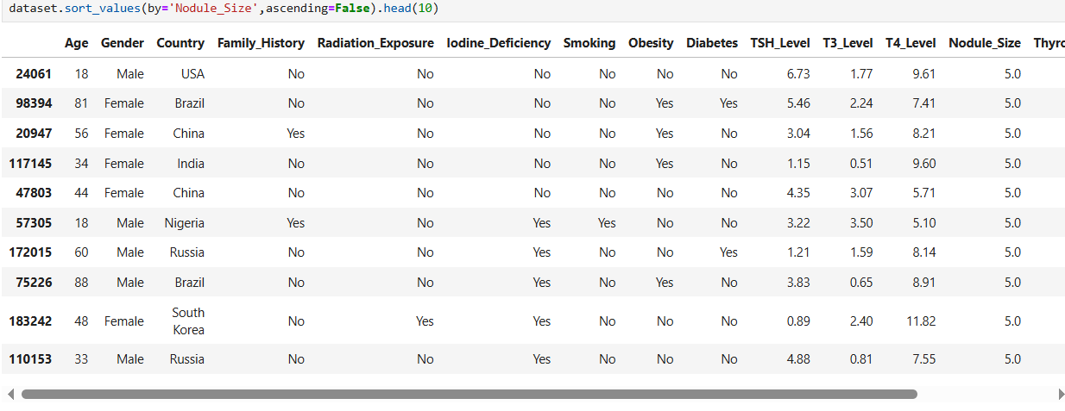

- Which patient from India has the largest Nodule Size?

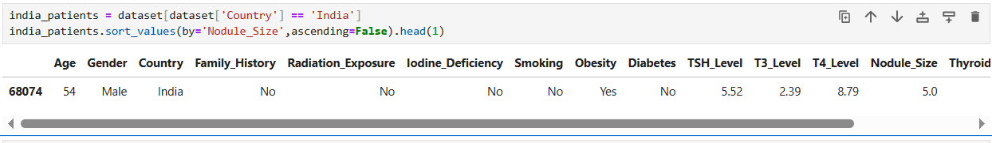

- Which countries have the highest TSH-Level for each Diagnosis type (Benign/Malignant)?
Diagnosis Country TSH_Level
Benign Brazil 5.075435
Malignant Japan 5.150928

- What is the average nodule size distribution of the high-Thyroid_Cancer_Risk for each Diagnosis type?

Diagnosis Nodule_Size
Benign 2.506930
Malignant 2.498084

- Which countries have the highest number of cases for each Diagnosis type?
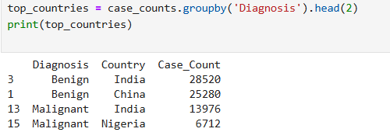

- Is there a relationship between Smoking and Thyroid Cancer Risk?
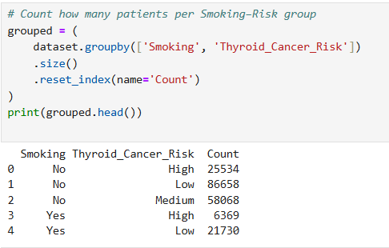

- Is there a relationship between Obesity and Thyroid Cancer Risk?

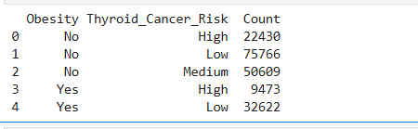

- Is there a relationship between Iodine deficiency and Thyroid cancer risk?

